呈：杨总监
Submitted by: Director Yang

容
大
H-9100 SP8G
低
压
喷
涂
油
墨
验
证
报
告
Verification Report of Rongda H-9100 SP8G Low Pressure Spray Soldermask Ink
编写： 李建民Prepared by: Li Jianmin
审核： 周小凯Review: Zhou Xiaokai
核准： 杨世杰Approval: Yang Shijie
日期：2020年10月24日 Date: October 24th, 2020

主题：关于容大H-9100 SP8G低压喷涂油墨验证报告
Subject: About the verification Report of Rongda H-9100 SP8G Low Pressure Spray soldermask Ink
一：目的 I. Purpose
公司快速发展、我司阻焊制程引进最新低压喷涂高端设备，实现进一步的提升阻焊制程能力，低压喷涂设备配合使用的专用喷涂油墨是容大H-9100 SP8G系列，在量产前研发部验证该系列油墨符合相关的品质要求，具体数据如下。
Due to the rapid development of the company, our production import of the latest low pressure spraying soldermask equipment,to achieve the further improvement of the solder mask capabilities. The special spraying soldermask ink used by Rongda H-9100 SP8G Series, which was verified by our R&D Department before mass production.They are conform to the quality requirements, the specific datas are as follows.
二：油墨相关规格和特性：II.Ink related specifications and characteristics
2.1油墨规格 2.1 Ink Specifications
颜色Colour | 绿 Green
混合比例 Mix proportion | 主剂：80% Main agent: 80% | 固化剂：20% Curing agent: 20% | 开油水：30ml/kg Boiling water: 30ml/kg
混合比例 Mix proportion | 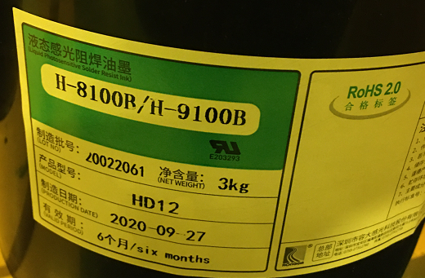 | 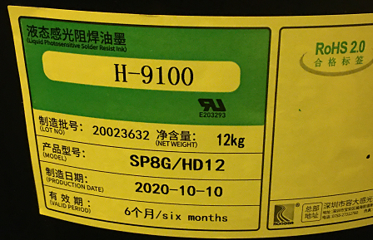 | 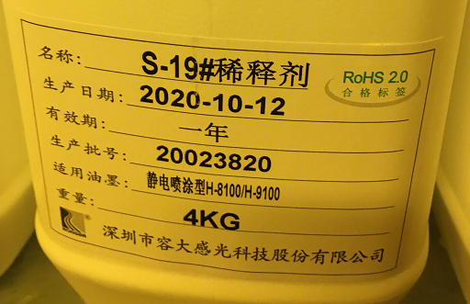
预烤参数 Precure parameters | 75℃±2℃ 60min
标准曝光能量Standard exposure energy | 300-500mj/㎝²

2.2油墨特性 2.2 Ink Characteristics
项目  Item | 试验条件 Test Conditions | 试验结果 Test Results
附着力Adhesion | 后烤完成后用3M胶带做剥离试验 After Postcure use 3M tape for peeling test | 无脱落  No shedding
铅笔硬度 Pencil hardness | IPC-SM-840C 3.5.2.1/IPC-TM-6502.4.27.2  刮痕以不破坏涂膜，看见铜箔表面为合格IPC-SM-840C 3.5.2.1/IPC-TM-6502.4.27.2  Scratches so as not to damage the coating film, and the copper foil surface is qualified | 6H  6H
耐焊锡性 Solder resistance | 浮锡方式：288℃/10秒×3次 Floating tin method: 288℃/10 seconds × 3 times | 无异常 No abnormality
耐酸性 Acid resistance | 10VO1%H2SO4室温下浸泡30分钟后用胶带做剥离实验 After soaking in 10VO1%H2SO4 at room temperature for 30 minutes, use tape for peeling experiment | 无异常 No abnormality
耐碱性 Alkali resistance | 10wt1%NaoH室温下浸泡30分钟后用胶带做剥离实验 After soaking in 10wt1%NaoH for 30 minutes at room temperature, use tape for peeling experiment | 无异常 No abnormality
三：验证流程 III.Verification Process
选定型号→磨板→喷涂→预烤→曝光→显影→后烤→性能测试→结论
Selected Model → Grinding Board → Spray Coating → Precure → Exposure → Developing → Postcure → Performance Test → Conclusion
四： 试验参数和性能测试结果 IV.Test parameters and performance test results
流程 Process | 要求参数 Required parameters | 实际参数 Actual parameter
前处理 Pretreatment | 酸处理→磨刷  Acid treatment → brushing | 酸处理→磨刷(正常磨板） Acid treatment → brushing (normal grinding board)
喷涂 Spray Coating | 速度：3m/min、喷枪70m/min  Speed:3m/min, spray gun 70m/min | 速度：3m/min、喷枪70m/min  Speed:3m/min,spray gun 70m/min
预烤 Precure | 75℃±2℃最高60min  75℃±2℃ up to 60min | 73℃ 48min  73℃ 48min
曝光能量Exposure energy | 300-500mj  300-500mj | 上灯400mj/下灯380mj  Upper light 400mj / Lower light 380mj
显影 Developing | 显影时间最高60秒 Development time is up to 60 seconds | 显影速度4m/min(55S)  Developing speed 4m/min(55S)
后烤 Postcure | 热风循环式烤箱150℃ 60min Hot air circulating oven 150℃ 60min | 隧道式后烤炉，150℃/55.8min Tunnel type oven, 150℃/55.8min
4.1试验参数 4.1 Test parameters
小结：容大H-9100 SP8G低压喷涂油墨所需要的参数条件在现有参数条件范围内，匹配制程生产。
Summary: Rongda H-9100 SP8G Low Pressure Spray Coating Ink requires parameter conditions within the scope of existing parameters, matching the production process.

项 目 Item | 试验条件 Test Conditions | 试验图片 Test picture | 结论 Conclusion
附着力Adhesion | 后烤完成后用3M胶带  做剥离试验 After Postcure use 3M tape for peeling test. | 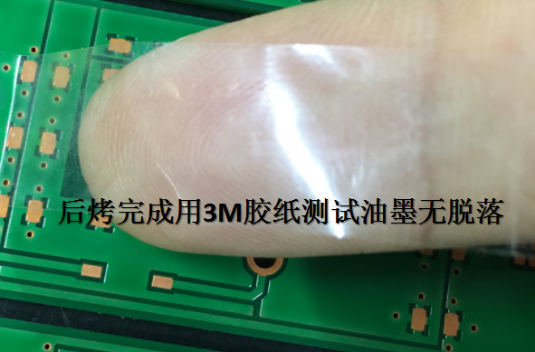 | 后烤完成后3M胶纸测试无脱落，合格。 After the postcure is completed, the 3M tape test does not fall off and is qualified.
铅笔硬度Pencil hardness | IPC-SM-840C3.5.2.1/  IPC-TM-6502.4.27.2  刮痕以不破坏涂膜，  看见铜箔表面为合格IPC-SM-840C3.5.2.1/IPC-TM-6502.4.27.2 scratches so as not to damage the coating film, and the surface of the copper foil is qualified. | 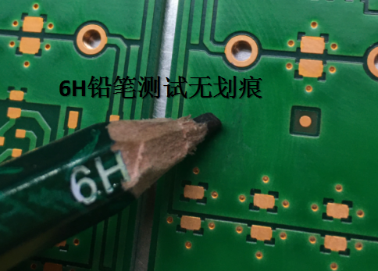 | 6H铅笔测试，油墨无破损，油墨面无划痕。 6H pencil test, the ink is not damaged, and the ink surface has no scratches.
4.2油墨性能测试 4.2 Ink performance test

耐焊锡性Solder resistance | 浮锡方式：288℃/10秒×3次 Floating tin method: 288℃/10 seconds × 3 times. | 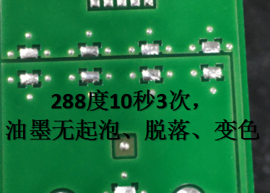 | 288℃/10秒×3次无起泡、脱落、变色，合格。 288℃/10 seconds×3 times without blistering, peeling, discoloration, qualified.
耐酸性Acid resistance | 10VO1%H₂SO₄室温下浸泡30分钟后用胶带做剥离试验 After soaking in 10VO1%H2SO4 at room temperature for 30 minutes, use tape for peeling test. | 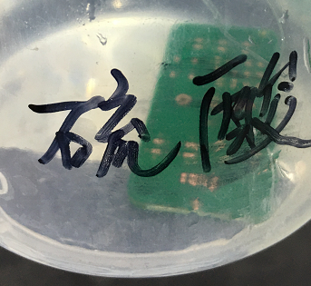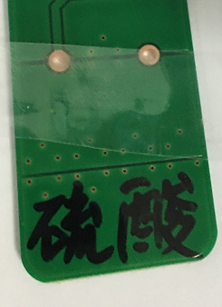 | 浸泡后用3M胶带做剥离试验无油墨脱落，合格。After soaking, use 3M tape to do a peel test without ink falling off, which is qualified.
耐碱性Alkali resistance | 10wt1%NaoH室温下浸泡30分钟后用胶带做剥离试验 After soaking in 10wt1%NaoH at room temperature for 30 minutes, use tape for peeling test. | 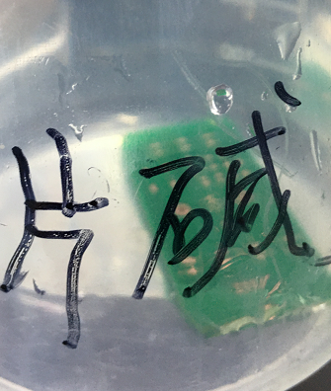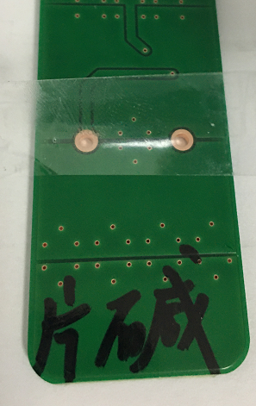 | 浸泡后用3M胶带做剥离试验无油墨脱落，合格。After soaking, use 3M tape to do a peel test without ink falling off, which is qualified.

4.3喷涂油墨厚度 4.3 Spray ink thickness
项 目 Item | 切片对比图 Slice Comparison Chart |  | 结论 Conclusion
油墨厚度 Ink thickness | 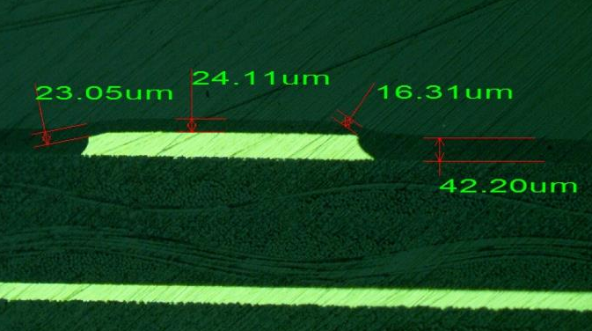 | 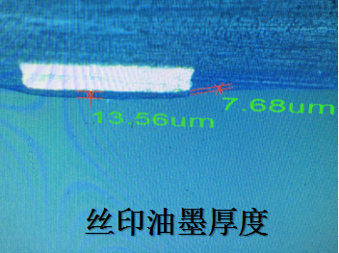 | 喷涂油墨厚度比丝印油墨厚度线面厚12um，拐角厚8um，符合要求。 The thickness of the sprayed soldermask ink is 12um thicker than the traditional printed soldermask on the copper, and the corner is 8um thicker than traditional printing, which meets they are conform to the requirements.
4.4油墨色差对比 4.4 Comparison of ink color difference
项 目  Item | 色差对比图 Color difference comparison chart |  | 结论 Conclusion
油墨色差 Ink color difference | 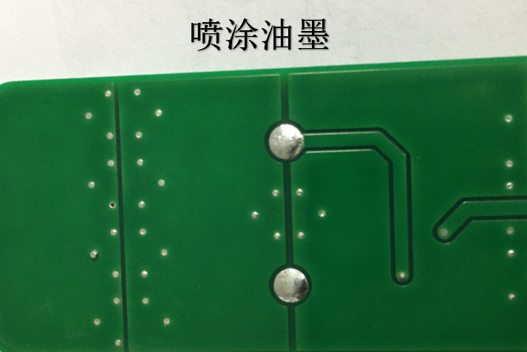 | 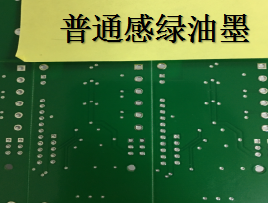 | 喷涂油墨与普通8G油墨，目视对比无明显色差，符合要求。 There is no obvious color difference between spraying ink and ordinary 8G ink, which meets the requirements.
小结：容大H-9100 SP8G低压喷涂油墨的附着力、油墨硬度、耐锡焊性、耐酸碱性都符合要求；喷涂油墨的厚度比丝印8-12um（提高pcb油墨耐漏电性能）；H-9100 SP8G低压喷涂油墨颜色与普通8G感绿对比，因为油墨偏厚一点，油墨悦色色差不特别明显。
Summary: Rongda H-9100 SP8G Low Pressure Spray Coating Ink's adhesion, ink hardness, soldering resistance, acid and alkali resistance are all conform to the requirements; the thickness of spraying soldermask ink is 8-12um thicker than the traditional printing soldermask (improving the leakage resistance of pcb ink);The color of H-9100 SP8G low-pressure spray coating ink is contrasted with that of ordinary 8G, because the ink is a bit thicker, and the color difference of ink is not particularly obvious.
五、结论：V. Conclusion:
经过对容大H-9100 SP8G低压喷涂油墨测试，确定该油墨管控参数在目前生产条件范围内，不需对参数进行特别调整，利于生产；油墨的各项性能符合质量要求，与常规8G感绿无明显色差，研发部申请可以投入生产使用。
After testing Rongda H-9100 SP8G Low Pressure Spray Coating Ink, it is determined that the control parameters of the ink are within the current production conditions, and no special adjustment of the parameters is required, which is beneficial to production; the performance of the ink meets the quality requirements, and is green with conventional 8G ,There is no obvious color difference, and the R&D Department apply for production.

